
CANDIDATE INFORMATION SHEET
APRIL 6, 2027 CONSOLIDATED ELECTION
OFFICES TO BE ELECTED – MAYOR AND COUNCIL DISTRICTS 1,2,3,4, AND 5 (4-year terms)
Informational Election Candidacy packets for the above-listed offices will be available in the City Clerk’s Office, located in the Joliet Municipal Building, 150 W. Jefferson St., Joliet, IL 60432.

Pursuant to referendums, the City of Joliet is organized as a council-manager form of local government with no primary election.

Candidates for Mayor and Districts 1,2,3,4 and 5, full-term (4 years) City Council positions, may begin circulating petitions for candidacy for the April 6, 2027, Consolidated Election on Tuesday, August 25, 2026.

Illinois law and applicable local ordinances impose qualifications to be eligible to submit nomination papers and to serve as an elected official. Candidates should review the applicable authorities to determine whether they meet the qualifications for office. This information sheet is provided as a courtesy for general informational purposes only and is not legal advice. Candidates are solely responsible for preparing, circulating, and filing legally sufficient nomination papers and all required accompanying documents. The City Clerk’s Office cannot advise candidates on whether their papers comply with law, and acceptance of papers for filing does not constitute a determination that the papers are valid or legally sufficient.
Candidacy petitions must be filed with the Joliet City Clerk’s Office between Monday, November 16, 2026 and Monday, November 23, 2026, during normal business hours of 8:00 a.m. to 4:30 p.m. The Joliet City Clerk’s Office will remain open until 5:00 p.m. on Monday, November 23, 2026, to accept petitions for candidacy.
A lottery to determine ballot position for the first ballot position and last ballot positions will be held (if there are simultaneous filings) at 9:00 a.m. Wednesday, December 2, 2026. All those candidates in line at the time of office opening on November 16, 2026 (for first position) and who file between 4:00-5:00 PM on November 23, 2026 (for last position) will be entered into respective lotteries. Ballot positions for all other filings are determined by the time and date order of filing.
For more information, please contact the Joliet City Clerk’s Office at (815) 724-3780 or cityclerk@joliet.gov. Please note the Joliet City Clerk’s Office will not be able to provide advice or directions on how to circulate petitions or submit them.
Please contact the State Board of Elections with any questions you may have regarding the Election process and review the 2027 Candidates Guide using the QR Code below:


IMPORTANT ELECTION DATES:

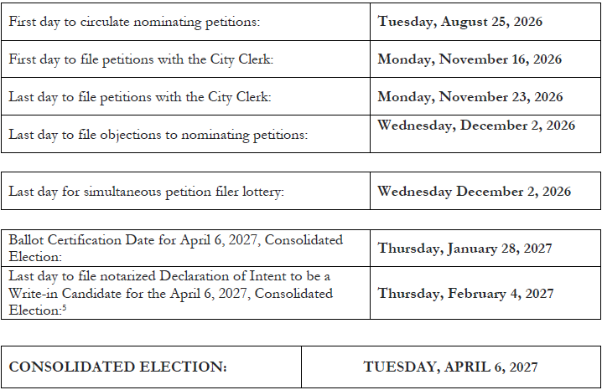

MINIMUM SIGNATURE REQUIREMENTS FOR NOMINATING PETITIONS
CITY OF JOLIET 2027 CONSOLIDATED ELECTION:
MAYOR AND COUNCIL DISTRICTS 1,2,3,4, AND 5 (4-year terms)
1% of the total vote cast in the City or in a given District at the last preceding election for Mayor.
[65 ILCS 5/4-3-8, 5/5-2-12; 65 ILCS 5/5-2-18.7, §§11-3(b) of the City of Joliet Code of Ordinances, Ordinance Number 7785]

The minimum number of valid signatures on nominating petitions needed for each office:
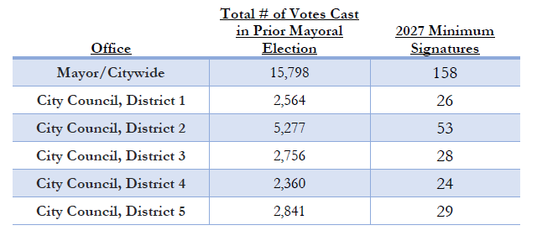
IMPORTANT NOTICE: The acceptance and certification of nomination papers by the Joliet City Clerk’s Office does not constitute a decision or ruling on the validity or legal sufficiency of those papers under the Illinois Election Code. Nomination papers may be challenged through the statutory objection process. Any such objection will be considered and decided by the appropriate electoral board, subject to judicial review. The Joliet City Clerk’s Office makes no representation or assurance regarding the outcome of any objection or other legal challenge.
CANDIDATE RESPONSIBILITIES: Candidates are responsible for completing their nomination papers completely and properly. Candidates are strongly encouraged to seek legal counsel to review their nomination papers before filing. A candidate’s responsibilities include, but are not limited to, filing the required number of valid signatures for the office sought; meeting the age, residency, district residency, and other qualifications for the office; numbering petition sheets consecutively; notarizing required documents; and ensuring the Statement of Economic Interests receipt is filed. This is not a complete list. For more information regarding nomination paper filing, candidates are encouraged to review the Illinois State Board of Elections’ Candidate’s Guide. A link to that guide is provided on the Joliet City Clerk’s website at: https://www.joliet.gov/government/departments/city-clerk-s-office/elections

These are preliminary calculations; candidates are responsible for ensuring that their nominating petitions contain a sufficient number of valid signatures. The relevant canvass book from the Will County Clerk’s Office is available here: https://assets01.aws.connect.clarityelections.com/Assets/Connect/RootPublish/willil. connect.clarityelections.com/Elections/2023ConsolidatedElection/CanvassBook.pdf

